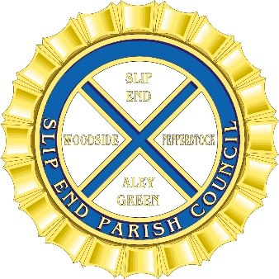
Slip End Parish Council

DD Celebrations – 8th June 2024
Village Hall – Slip End

Remembering D-Day and the Battle of Normandy
The D-Day landings of 6th June 1944 was the largest seaborne invasion in history. Along with the associated airborne operations, it marked the beginning of the liberation of France and western Europe.

Slip End Parish Council are organising an afternoon tea event for the residents of Slip End, Woodside, and Pepperstock on Saturday 8th June 24 to mark the 80th Anniversary of D-Day. It will be a tea party with music of the time and information about D-Day and War on the Home Front. Dressing up is optional.

We need some help from residents, to volunteer to organise / run the event.

We also would like to hear from anyone who has any family stories photographs of war time in the parish of Slip End which they are happy to include in our War on the Home Front Display.

We want it to be a great event, everyone is invited, so please save the date in your diaries.

I intend to hold a meeting for all those who are interested in helping and I will let you know the date as soon as I have numbers. I look forward to hearing from you.

If you can help, please contact me:
Clerk: Tracey O’Neill – clerk@slipendparishcouncil.co.uk
Contact: 07487 805249

